Faculty of Engineering and Computer Science
Department of Mechanical Engineering



ENGR-391 Numerical methods for Engineers

Student’s Name:

I.D.:

Duration 3 hours

- Read carefully all questions
- Write all the steps you need to find the solution
- Please do not write in red (colour used for correction)
- Write all your answers in the foreseen places
- Everything not readable will NOT be corrected

PROBLEM 1 [Solving Nonlinear Equations] [5 marks]

Consider following equation:

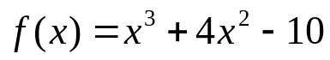

i) Find an interval of length 1 (i.e. b-a=1) containing its first positive root.

ii) Solve the equation using the bisection method using your interval from i)

 |  | 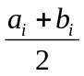 | Signe of 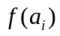 | Signe of 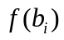

Give you approximation for the root with 3 significant digits:

PROBLEM 2 [Solving Systems of Linear Equations] [5 marks]

i) Find the LU decomposition of following matrix:

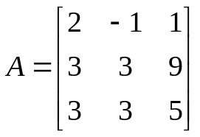
Hint : Check your results

ii) Comment following statement: As the naïve Gauss elimination algorithm is an exact algorithm (no approximations) it is insensitive to ill-conditioned problems.

PROBLEM 3 [Numerical Integration]

a) [5 marks]

Compute the following integral:

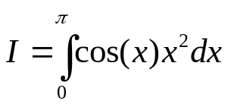
Using multi-segment Trapezoidal rule with two segments (n=2) and with four segments (n=4).

Estimate your global truncation error and give your answer with an appropriate number of significant digits.

Hint: The order in the global truncation error of the trapezoidal rule in its multiple application is order 2.

b) [5 marks]

Compute the following integral:
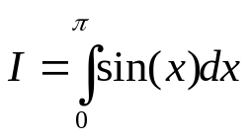
using Romberg’s method. Therefore complete following table

0
1.57079633
1.89611890
1.97423160
1.99357034

Give your final answer (the value of I) with as many significant digits as you can guarantee to be correct and an estimation of the error.

c) [5 marks]

Recall that the trapezoidal rule in its multiple version is written as:

- 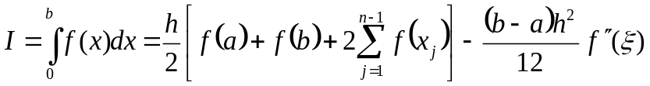, 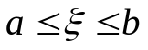
Using (1) estimate h and n such that 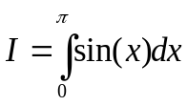 can be evaluated with an absolute error 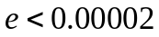.

PROBLEM 4 [Solving Ordinary Differential Equations]

a) [5 marks]

Solve the following ODE:

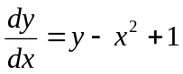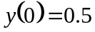

using Euler’s method, for 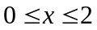 and a step of 0.2.

 |  | 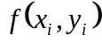

b) [5 marks]

Consider following initial value problem:

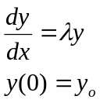 with 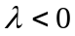

i) If 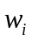 is the approximation obtained with Euler’s method (explicit) using a step size h after i iterations (i.e. i=0 gives 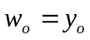, 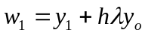, etc…), give a general expression for

ii) To study the effect of round-off error propagation we consider that 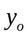 is approximated as follows: 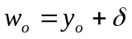 (i.e. is the round-off error added to ).
Compute the round-off error 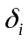 at step i.

PROBLEM 5 [Lagrange interpolation] [5 marks]

Compute 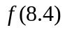 of following function by Lagrange interpolation.

 | 8 | 8.1 | 8.3 | 8.6
 | 16.63553 | 17.61549 | 17.56492 | 18.50515

Hint: first determine the Lagrange interpolation polynomial and then evaluate it in 8.4

PROBLEM 6 [Least square method] [5 marks]

Consider following points:

 | 1.0 | 1.1 | 1.3 | 1.5 | 1.9 | 2.1
 | 1.84 | 1.96 | 2.21 | 2.45 | 2.94 | 3.18

Following model is used to adjust the data:

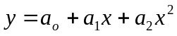

Write down the normal equations (in matrix form) for this model and above data

